PRSEF Research Plan
2022-2023
Engineering Projects

All projects must have a Research Plan written prior to experimentation following the instructions below to detail the rationale, research question(s), methodology and risk assessment of the proposed research.
(Research Plan/Project Summary Instructions, ISEF Rules and Guidelines, page 33).

Title of Project
Name
School
Category
Teacher

Question or Problem being addressed

Rationale
Brief synopsis of the background that supports your research problem and explain why this research is important scientifically and if applicable, explain any societal impact of your research.

Engineering Goals/Expected Outcomes
How is this based on the rationale described above?

Materials List
List of all items used in research. Make sure to include concentrations of all chemicals, source and amount of all living organisms, and all equipment used.

Procedures
Numbered step by step detail of procedures and engineering design to be used for data collection including proper disposal if needed. See guide below to determine if you need additional approvals. Keep in mind that if you use someone besides yourself to test your product, you will need human subject forms. Refer to ISEF rules and guidelines for further instructions.

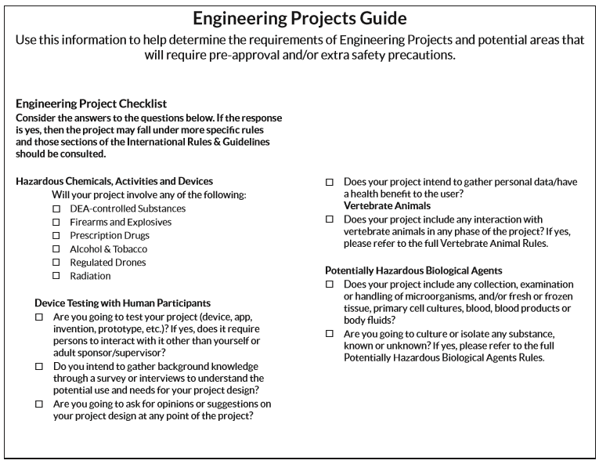

Step by Step Procedures
Make sure to clarify which procedures were completed by the researcher and which were completed by others.

Risk and Safety
Identify any potential risks and safety precautions needed.

Data Analysis
Describe the procedures you will use to analyze the data that determines if the engineering goals were met.

Bibliography
List at least five (5) major references (e.g. science journal articles, books, internet sites) from your literature review. Please use a variety of sources, five sources from the internet will not suffice.
- Must be in MLA or APA format.
If you plan to use vertebrate animals, one of these references must be an animal care reference.
- If you plan on using human subjects, one of these references must be from the listing of human subject reference in the ISEF Rules and Guidelines.
- Include MSDS/SDS citation for all hazardous chemicals used in experimentation.
- If you plan on using PHBAs, one of the references must include aseptic technique.
- Include ISEF rules book – pages that refer to your specific topic.

List of possible references/resources are included in the ISEF Rules and Guidelines, pages 23-25.

Adult Sponsor ________________________________________________ Approval Date __________________

